Weddings

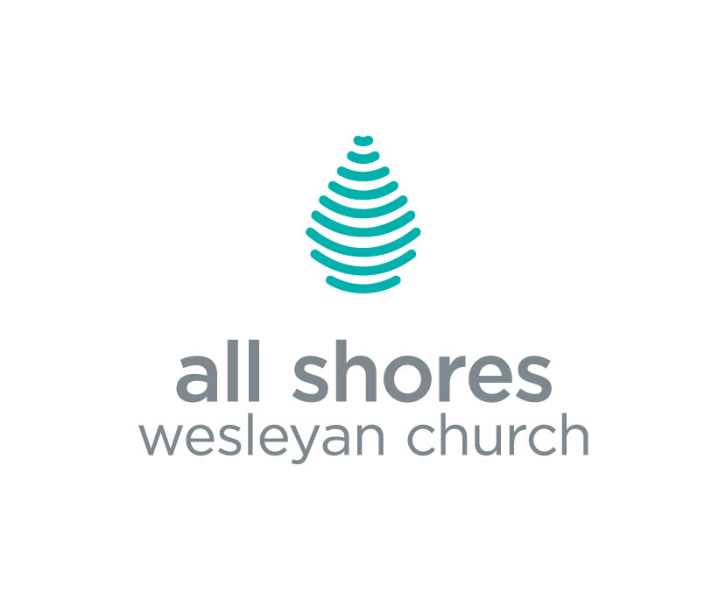



Congratulations Bride & Groom

Congratulations on your engagement! We are pleased and honored that you have invited All Shores Wesleyan Church to serve you as you prepare for your wedding. The plans you make in the coming weeks and months will make wonderful memories. Also, your participation in the premarital process shows a strong commitment to grow your relationship in ways that honor God and each other.

We’re here to assist you in every way possible. To get started, please complete our online Wedding Request and we will contact you as soon as possible to confirm your wedding date. If you have any questions, please contact our church office at 616-842-9022.

All of us here at All Shores look forward to serving you and your family during this special time!

Officiating Pastors

Each pastor here at All Shores Wesleyan Church would be honored to take part in this very special day by officiating your wedding (pending availability).

Officiating pastors include Peter Yoshonis, Steve Rimes, Thad Spring, EJ Wood, Amy Sheridan, Aaron Fongers, Patrick Cooper and Brandi Hafler. Click here to check out our pastoral staff profiles.

Our Facility

After you have submitted our online request form, we will contact you to confirm that our facility is available for your requested wedding date. Once confirmed, a $100 deposit is required to book your wedding. This deposit is made payable to ASWC and will be deducted from the rental cost.

Weddings may be scheduled for any day available on the church facilities calendar, with the exception of Sundays. (Nationally recognized holidays and/or church office closures may have an additional booking fee.)

Saturday weddings that take place in the Worship Center must be completed by 6:00 p.m., including photos, so that our facilities team is able to prepare for Sunday morning services.

Limitations
No alcohol is permitted in or on All Shores Wesleyan Church property. Smoking is only allowed outside of the facility.

Wedding Packages
Please scroll down to the next page to review the details of the wedding packages we offer. Only some charges may apply when using an outside pastor or when using an All Shores pastor for an offsite wedding. Ask our wedding coordinator for details.


STANDARD PACKAGE $1200 ($100 deposit)
WORSHIP CENTER – 900 seats

Officiating Pastor
Spacious lobby/café area
Downstairs gathering area/restroom for bride & attendants
Upstairs gathering area/restroom for groom & attendants
Wedding Coordinator - two planning meetings, wedding rehearsal, wedding day
Facilities Services - cleaning and maintenance before and after wedding
Wedding Rehearsal - typically the day before, time to be scheduled
Technical Support - lighting and sound tech during ceremony and rehearsal
Premarital Counseling - personalized couple’s counseling in a minimum of 3 sessions by officiating pastor, online premarital assessment taken by both bride and groom prior to the first session to be used by pastor. ($35 assessment fee paid to independent website – not included in package pricing)

OUTDOOR PACKAGE $1000($100 deposit)
WATERFRONT GAZEBO & PARK

Officiating Pastor
Gazebo Ceremony*
Natural beauty with water view
Indoor restroom/gathering space for bridal party
Indoor public restrooms
Wedding Coordinator - two planning meetings, wedding rehearsal, wedding day
Lawn Care - grass to be mowed 2-3 days prior
Facilities Services - cleaning and maintenance before and after wedding
Wedding Rehearsal - typically the day before, time to be scheduled
Premarital Counseling - personalized couple’s counseling in a minimum of 3 sessions by officiating pastor, online premarital assessment taken by both bride and groom prior to the first session to be used by pastor. ($35 assessment fee paid to independent website – not included in package pricing)
*Wedding Party to supply, set up, and remove extra seating along with any other décor or supplies used.

