ALL SHORES GROUPS COACH’S GUIDE
CHURCH OF THE HIGHLANDS

2

God’s process for people to find freedom begins with having the right people in their lives. He designed us for community, and connecting in groups is how we help people find life-changing relationships at All Shores.

Your role as a Groups Coach is a vital part of successful groups at All Shores. Just as Group Leaders care for their groups, as a Coach, you care for the leaders. By covering leaders in prayer, developing a relationship with them, and serving as a resource, you are helping strengthen leaders and the powerful ministry of groups.

The model for leadership covering in groups is based on a principle we see in the Bible modeled by Jethro, the father-in-law of Moses.

“Moses’ father-in-law replied, ‘What you are doing is not good. You and these people who come to you will only wear yourselves out. The work is too heavy for you; you cannot handle it alone. Listen now to me and I will give you some advice, and may God be with you…select capable men from all the people—men who fear God, trustworthy men who hate dishonest gain—and appoint them as officials over thousands, hundreds, fifties and tens….If you do this and God so commands, you will be able to stand the strain, and all these people will go home satisfied.’”
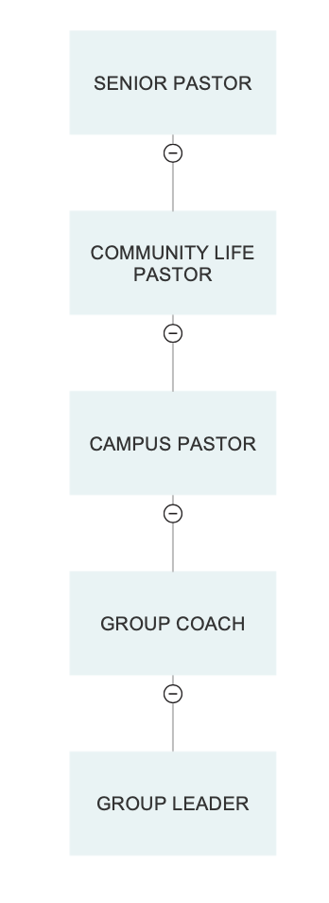
EXODUS 18:17–23

THREE AREAS OF FOCUS FOR COACHING

- PRAY

The most impactful thing you can do is pray for your leaders. As you agree in prayer with your leaders, God promises to move.

“Again, I assure you: if two of you on earth agree about any matter that you pray for, it will be done for you by my Father in Heaven. For where two or three gather in my name, there am I with them”

MATTHEW 18:19–20

Leading a group at All Shores isn’t something any of us are asked to do alone. Your role as a Coach gives leaders support as you carry the responsibility to care for people together.

- CONNECT

Cultivate a personal relationship with your leaders.
Take time to get to know your Group Leaders. Learn about their story, spiritual journey, and what motivates them to lead a group. Knowing them on a personal level will not only help you serve them well, but it is also in line with how God tells us to care for the people He has allowed us to influence.

Be sure you know the condition of your flocks, give careful attention to your herds.

PROVERBS 27:23 NLT

Communicate helpful information.
You are the Group Leader’s direct line of communication. Throughout the semester, regularly communicate information that will help them lead well. This can look like reminding them to be praying for their group, encouraging them to help people move one step, directing them to the Next Steps Survey, or helping them decide where to host their group or how to invite people to attend.

Don’t know the answer to a question? This is why you have support, too! Reach out to your Groups Coordinator or Community Life Pastor to help you support your leaders as needed.

If you encounter a difficult situation with your Group Leaders, the team is here to support you. If one of your leaders is going through a crisis, you can provide prayer, encouragement, and support. Use wisdom and be sensitive to the situation. If you are unsure of what to do, don’t hesitate to ask your Groups Coordinator.

- GROW

We are called to identify and develop leaders.

The harvest is great, but the workers are few. So pray to the Lord who is in charge of the harvest, ask him to send more workers into his fields.

LUKE 10:2 NLT

Help your leaders move one step.
You have the opportunity to invest in your leaders by helping them grow and move one step in their leadership. By praying for them, asking the Holy Spirit for guidance, and connecting with them personally, you will be able to help them take next steps.

Questions to ask:

  - What is one area you hope to grow this semester?

  - How can I pray for you?

  - What is an area of leadership that is challenging for you?

  - What do you feel God is calling you to do through Group leadership?

Help your leaders develop new leaders.
By developing your leaders, you are modeling how they can develop leaders in their group. You can also help them identify potential leaders.

Here are a few ways to do this:

  - Ask about potential leaders they have identified in their group.

  - Help them know what to look for in potential leaders such as participation, a willingness to help, spiritual growth, and a connection to the life-giving culture of groups.

  - Remind them to invite potential leaders to watch the Group Leadership Training online at allshores.org/training.

PRACTICAL COACHING IDEAS

Throughout the semester as you pray, connect, and grow your leaders, here are some practical ways you can care for them:

Make a connection at the beginning of the semester.

- Introduce yourself and exchange contact information.

- Share more about your role as a Coach and how you will support them throughout the semester you will:

  - Pray for them
  - Answer questions
  - Remind them of important steps like the Next Steps Survey and helping group members move one step
  - Help them develop as a leader
  - Help them identify potential leaders in their group
  - Be available to help and support them

- Give ideas for inviting people to attend their group such as:

  - Think of people in their sphere of influence like co-workers, friends, and neighbors
  - Be aware of people new to the church, new believers, or have shown interest in getting involved
  - Look for people who have leadership potential
  - Ask God to send the right people to your group

Visit your leader’s group during the semester, especially if they are a first-time leader.

- Communicate when you’ll be visiting the group in advance.

- Remind the leader that the purpose of your visit is to support them and invest in the ministry they are personally doing.

- Be on time and participate. You are not there just to look over their shoulder!

- Ask the leader to introduce you to the group so that everyone feels comfortable.

- Evaluate if the group has the life-giving culture of All Shores Groups.

- Make notes of feedback or ideas that will help the leader continue to strengthen the group and grow their personal leadership.

- Encourage the leader and celebrate the wins. Do you see things like genuine relationships formed, people engaging in conversation, and group members openly sharing prayer needs? These are signs of a healthy group and should be celebrated! If you don’t see these things, guide the leader on ways to cultivate these group dynamics throughout the rest of the semester.

- Help the leader identify potential leaders in their group.

- Remind the leader how they can help people move one step.

Maintain a relationship with your leader.

- Create opportunities to connect with leaders over coffee, lunch, or before or after services on Sunday.

- Send email and text updates to leaders reminding them about upcoming opportunities at All Shores like baptism, conferences, and 21 Days of Prayer.

- Help them accomplish important goals like group rosters and attendance, the completion of the Next Steps Survey with their group.

- Host an end-of the-semester celebration with your leaders.

EFFECTIVE GROUP MEETINGS
Here are some guidelines on what to look for when you visit a group, and areas to help the leader grow as needed.

Leadership Skills

- The leader is helping members move one step in their faith.

- New leaders are being identified and encouraged to watch Group Leadership Training.

- The objectives of the meeting are accomplished.

- The leader stays involved and listened to everyone.

- The relationship between the leader and the group members feels healthy.

- The leader prays during the group.

- The leader stays on topic.

- The meeting starts and ends on time.

Group Dynamics

- The group maintains a life-giving environment.

- Everyone participates in prayer time.

- Members participate in discussion and are engaged.

- Everyone is included, and no one overwhelms the conversation or is completely left out.

Care

- The leader allows time for ministry to happen within the group.

- The leader emphasizes the Next Steps Survey.

- The leader asks for prayer requests.

NEXT STEPS

One of the best resources you can direct your Group Leaders to is the Next Steps Resource a part of our Group Leader FAQ document. The goal for every group is to help each person move one step forward in their faith. As a Coach, you can help leaders keep this a priority and help them implement practical ways to help people move one step.

Coaches play an important role in the Next Steps Survey as well. The Next Steps Survey helps us measure the health of groups and how our church is growing spiritually. A link to the Next Steps Survey is sent out to Group Leaders in the middle of the semester, and you will help ensure leaders, co-leaders, and their groups complete the survey.

BEING PART OF THE GROUPS TEAM

As a Coach, you are an important part of the Groups Team. Not only can you help your leaders grow, but you can also help strengthen the groups ministry as a whole in the following ways:

- In addition to praying for you leaders and their groups daily, also pray for God’s favor and direction over the entire groups ministry as we help people find freedom.

- Help complete Group Leadership Training Interviews with new leaders at the beginning of each semester.

- Participate in the recruitment of new leaders at your campus as directed by your Groups Coordinator.
- Ensure your leaders and their groups complete the following:

  - Group Rosters
  - Next Steps Survey

